How to create a CSS Template
Step 1 - On the loading screen select CSS from the central column.
Select CSS Styles from the right hand side of the screen by double clicking on it.
Select All from the two tabs.
Step 2 - Right click inside the area and select New
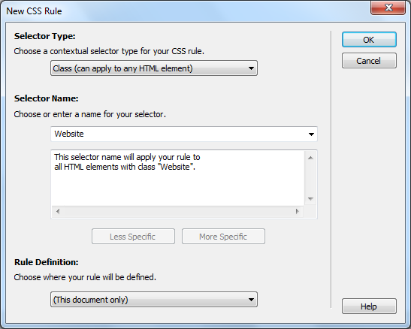
Give the style a name in the name box and click on OK
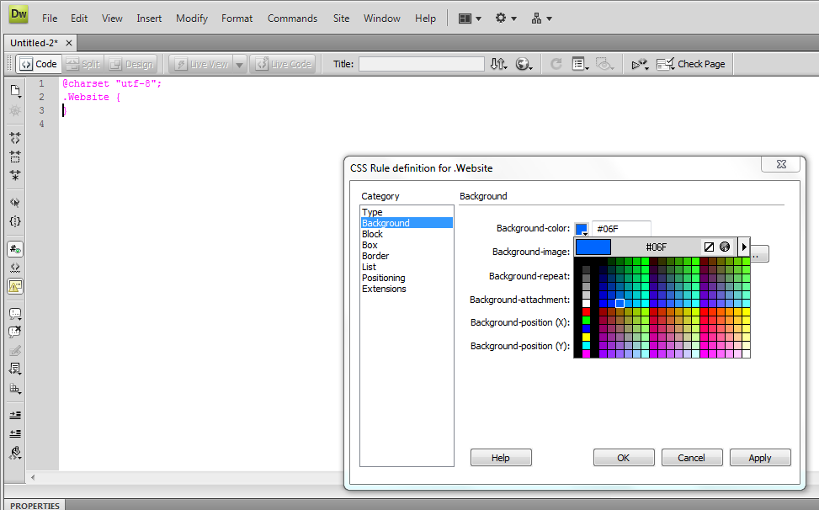
Choose the colour you selected for your background colour in the previous tasks.
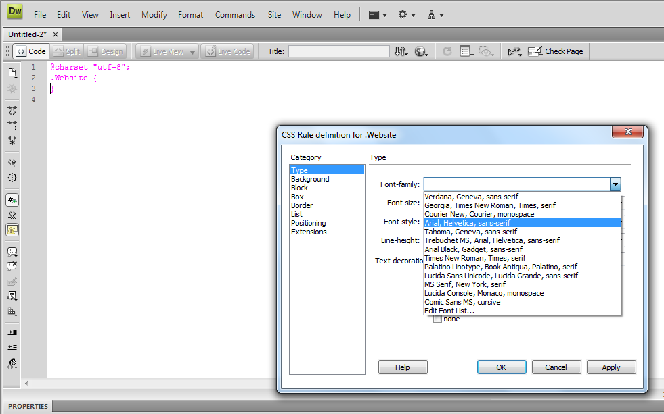
Click on Type and select the main text font type you want that you choose in your plans.
Then choose the font family, font size and font colour that you choose in your plans. Make sure you change the font-size number to PT rather than PX.
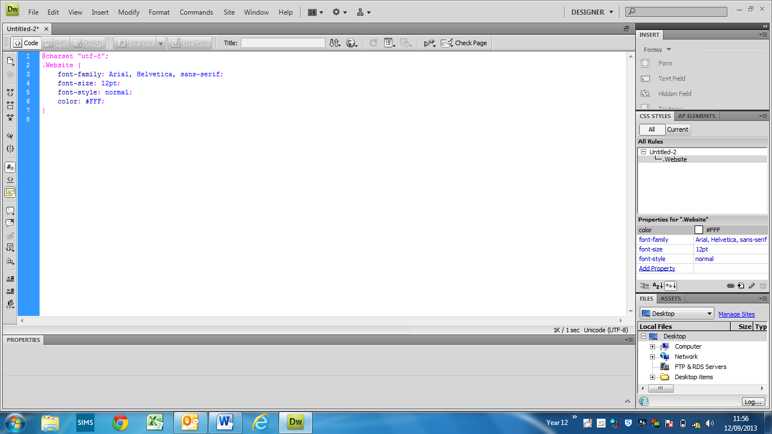
Click on OK and it should look like the above.
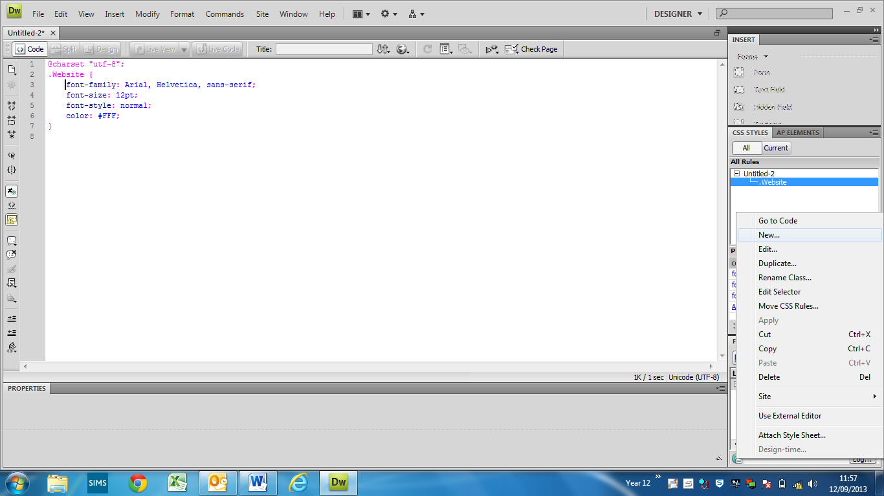
Step 3 - Next right click in the white area under CSS styles and choose new again.
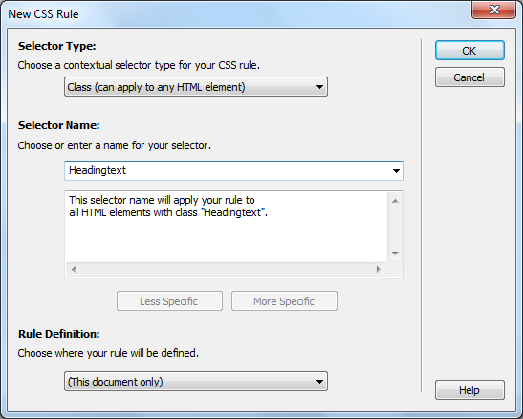
Call this Heading and select OK. Make sure you do not put in a space.
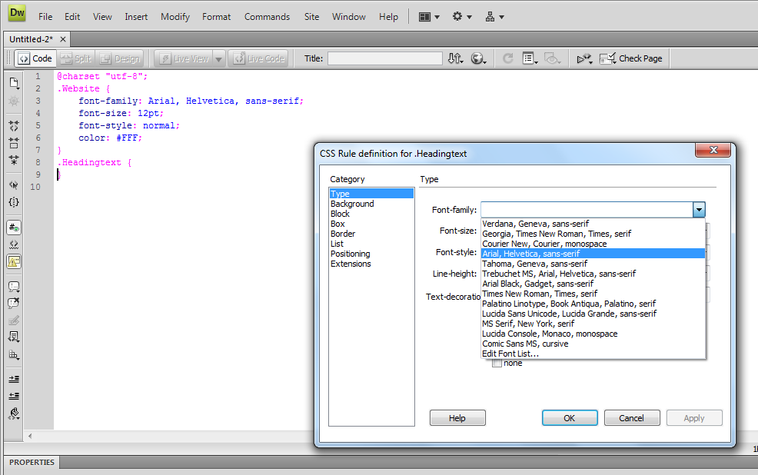
Change the font again for the Heading text
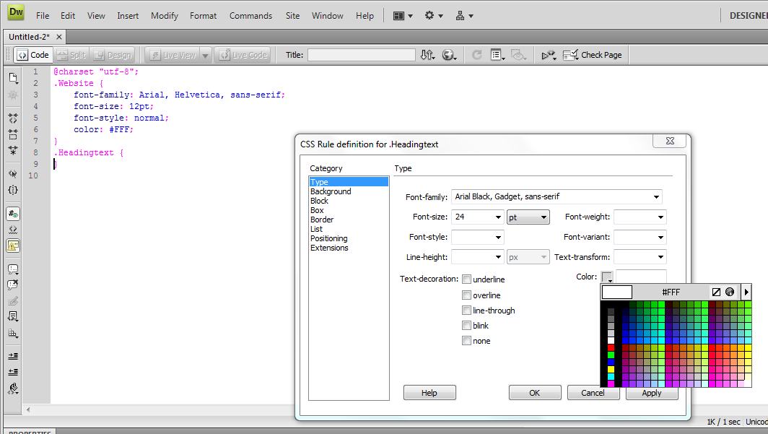
Change the size and colour of the heading text to the things you choose in an earlier task. It should be the same as Step 2 but the size should be double the number you choose.
Step 4 - And one more time, select new again from the right hand side.
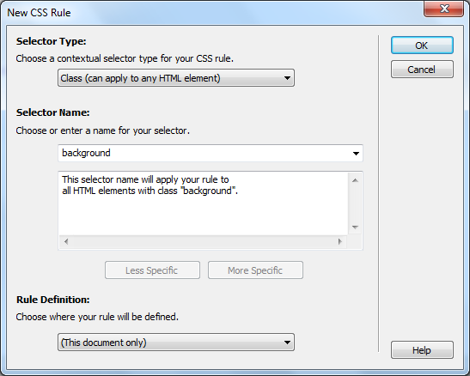
Call it background and click on OK
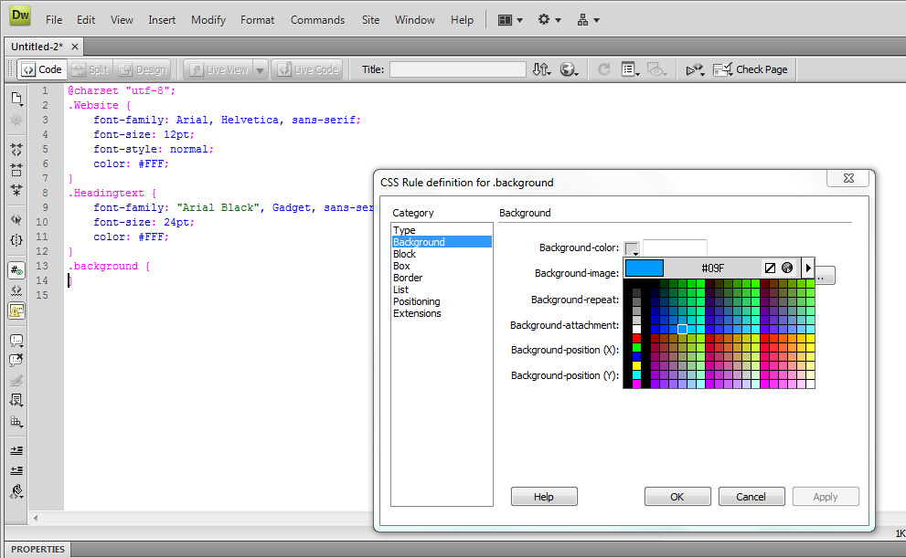
Click on Background and select the background colour for your page and select OK
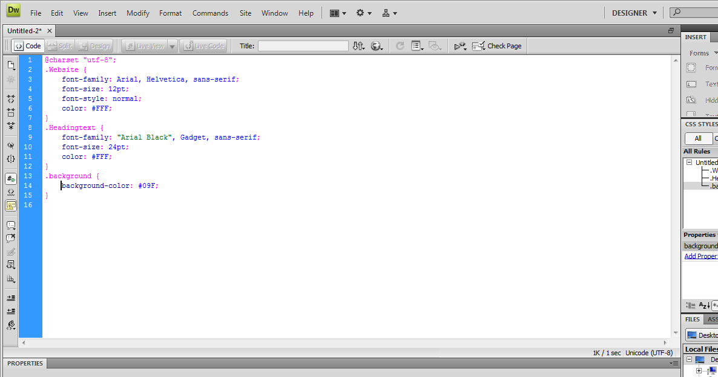
You code for the CSS should look like this.
Step 5 - Click on File and Save As.
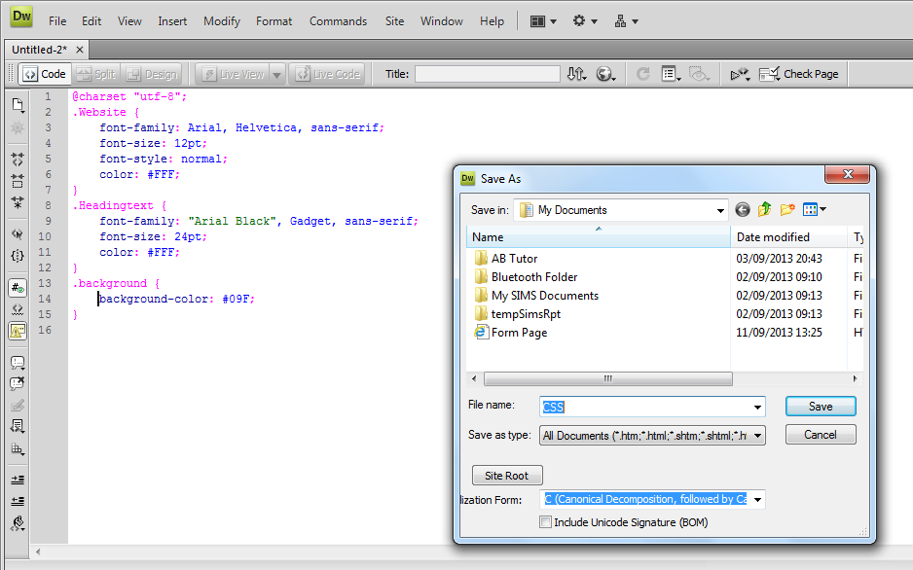
Call it CSS and choose your website folder you created.
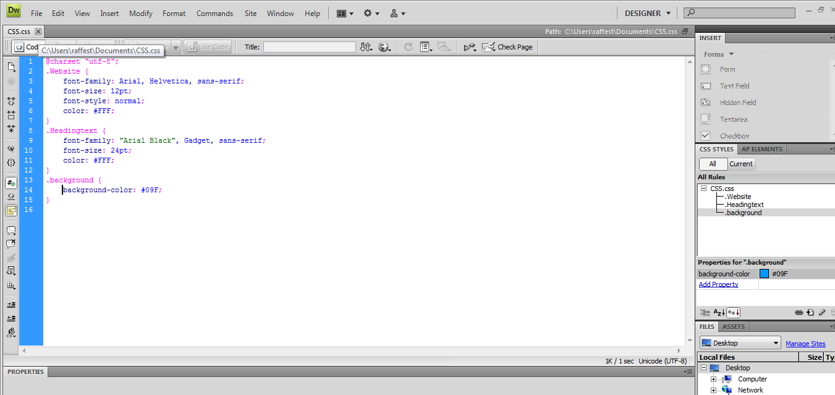
Close down the File and go back to the Dreamweaver main screen.
Step 2 - Start a new HTML document from the middle column on the screen.
On the right hand side under properties there is a small symbol looking like a figure 8 on its side, click this.
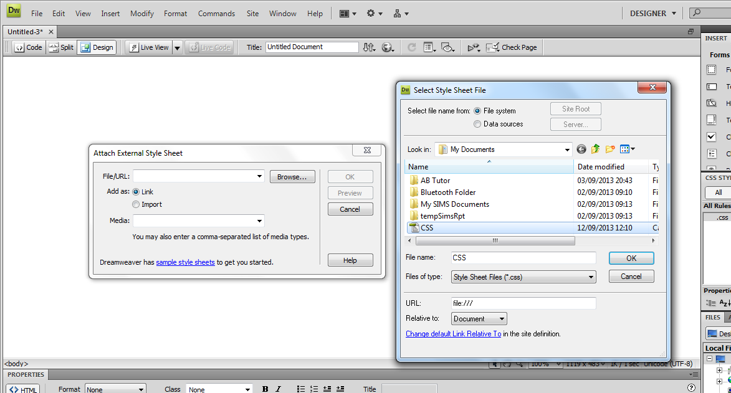
Browse for the file you saved called CSS and click on it.
It will appear as a blank screen still, this is fine, the styles are still there.
Step 3 - Insert a table by clicking on Insert and select Table
Make it 3 by 3 and click on OK
Step 4 - Click on the bottom right hand corner and drag the box so it is 4 times the size
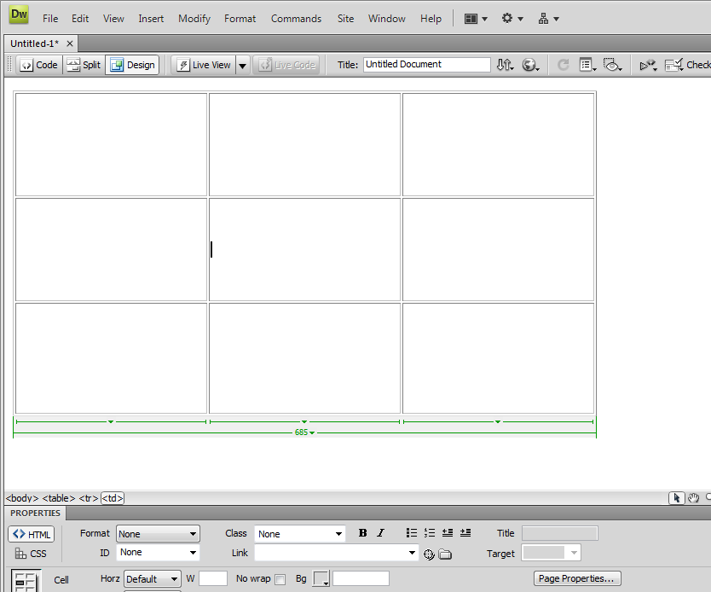
Should now look like this. Click the mouse into the middle cell.
Click on Modify at the top of the screen.
Choose the background colour from earlier.
Choose the text colour from your template file. Then click on OK.
Your page should now have the background colour and table.
Step 10 – Click where you want the logo to be and click on Insert and Image.
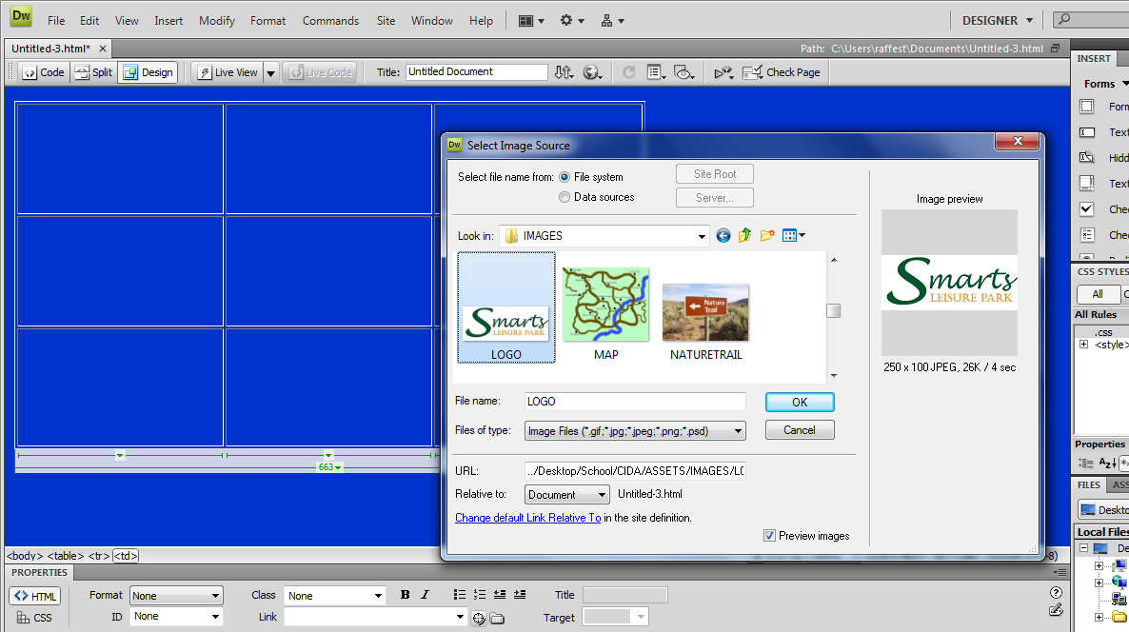
Inside the Assets folder you should find the Logo file for your Company. Ignire the box that pops up afterwards.
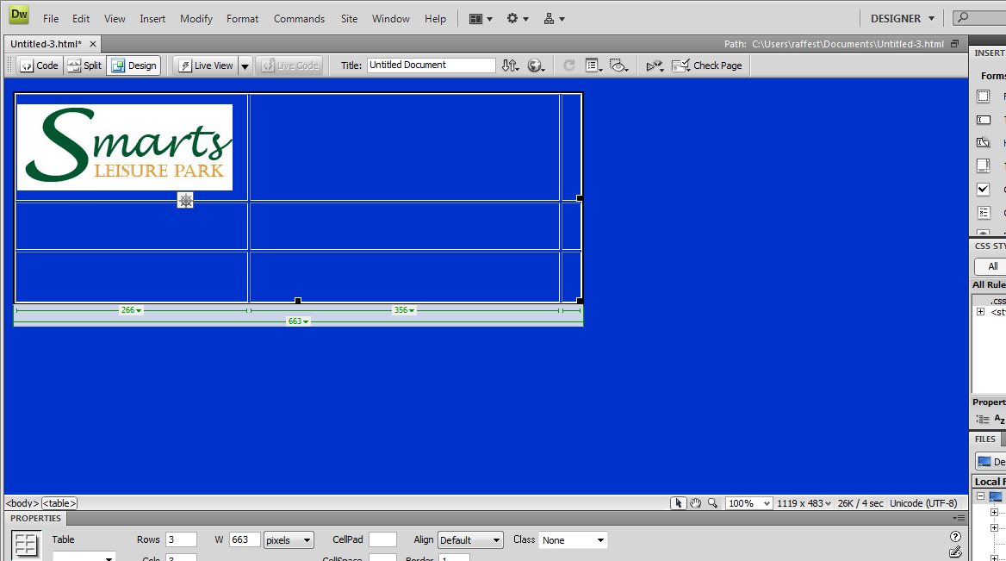
Drag the lines in so the logo fits inside the table like above.
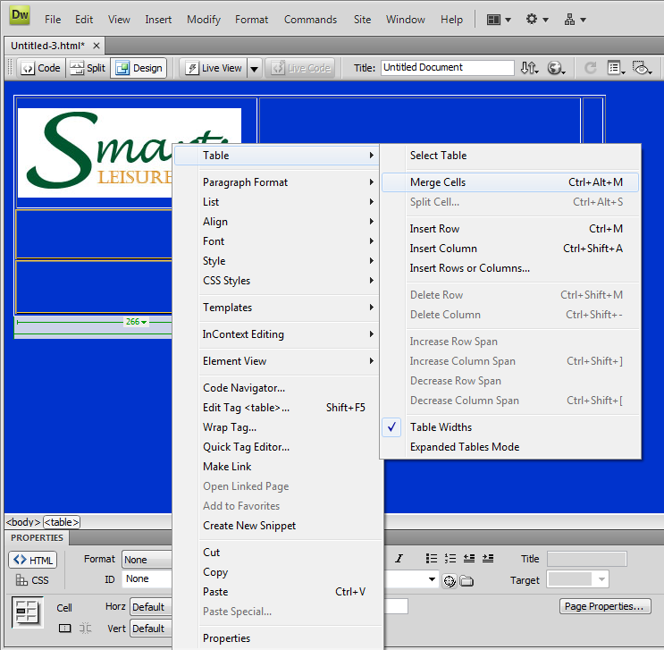
Highlight the cells you want the buttons to be in and right click and select Table and Merge cells.
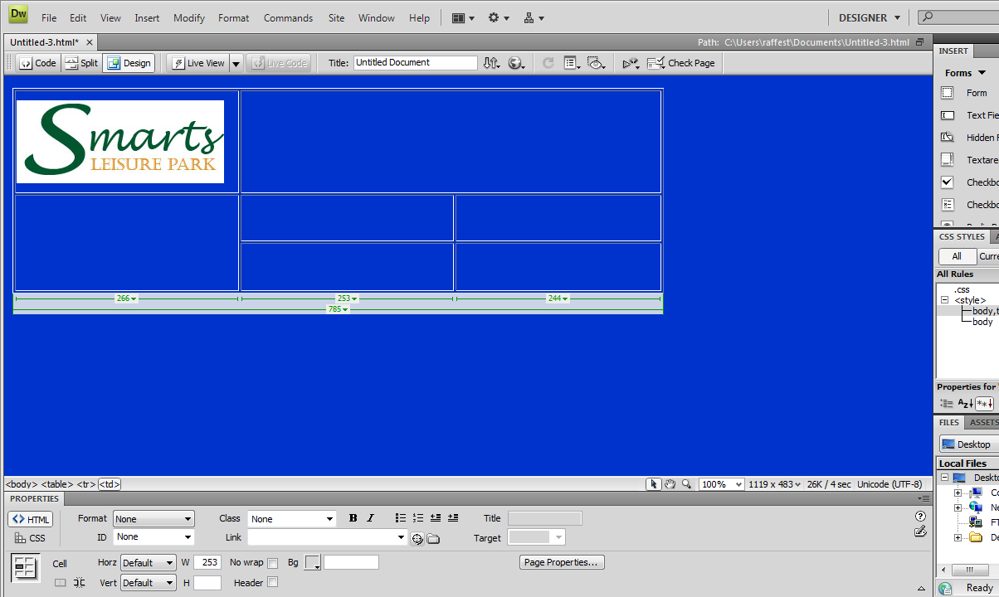
Your finished CSS should look like this. Save the page now five times called whatever names you pages will be on the Site map.

